**Assignment 2:**

**Course: Mobile App Development**

**Create Splash Screen**

**Minahil Sajid**

**19-Arid-813**

**Submitted to: Sir Azhar**

**Splash screen is the basically a screen which is shown a few second before launching an application for activity**

**Step 1:**

First we create an activity with name splashscreen813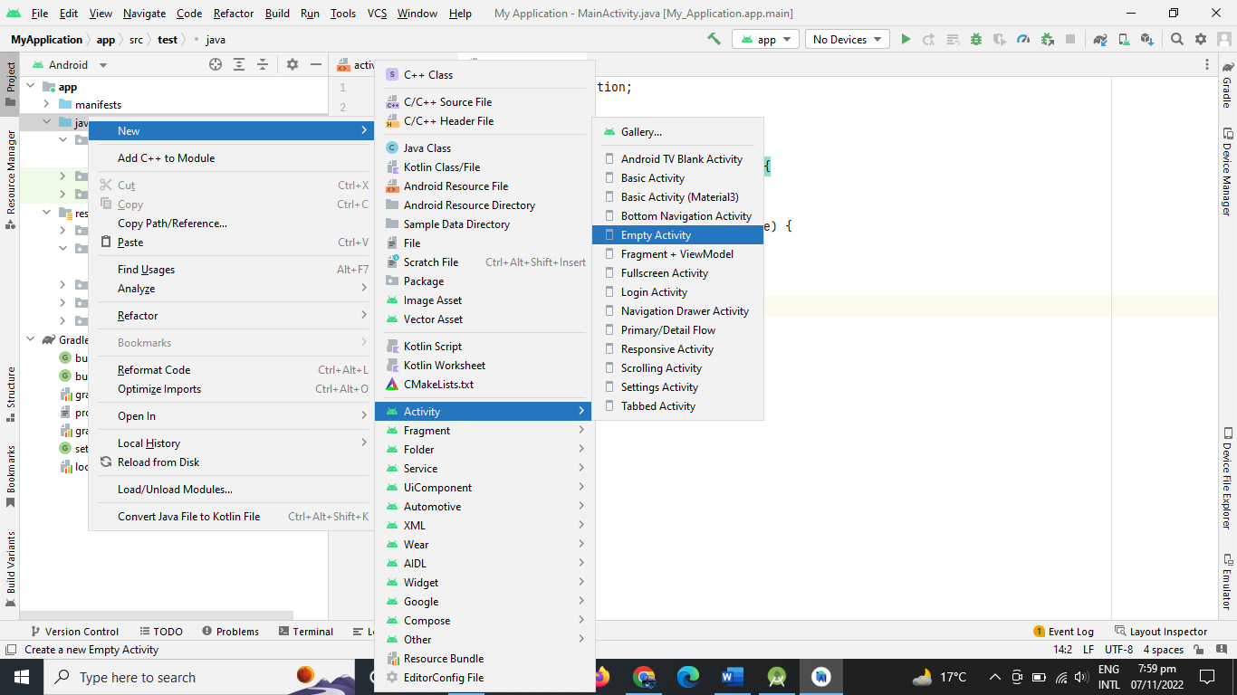

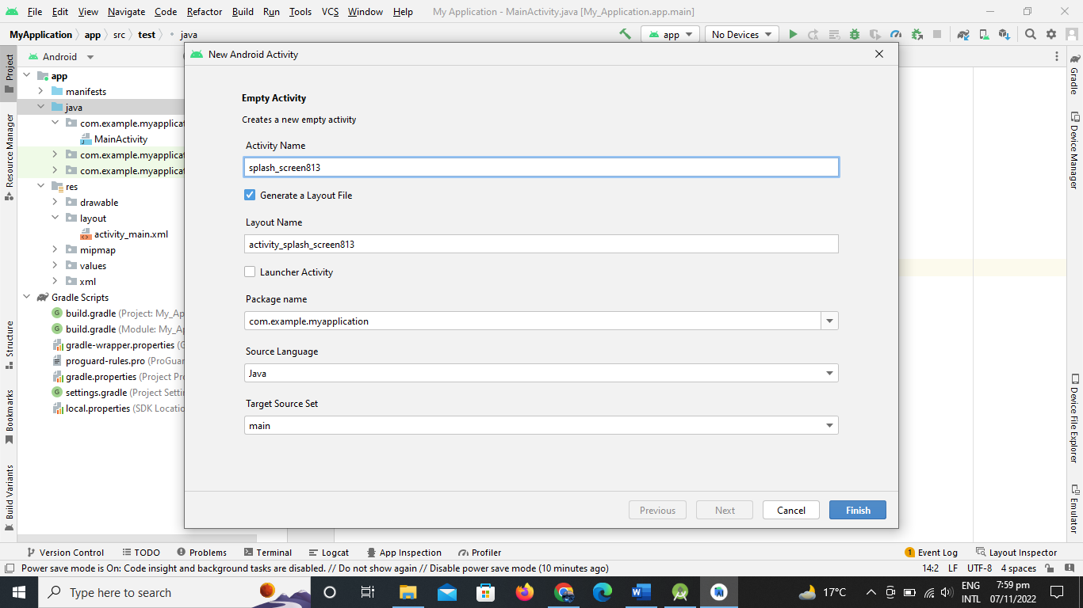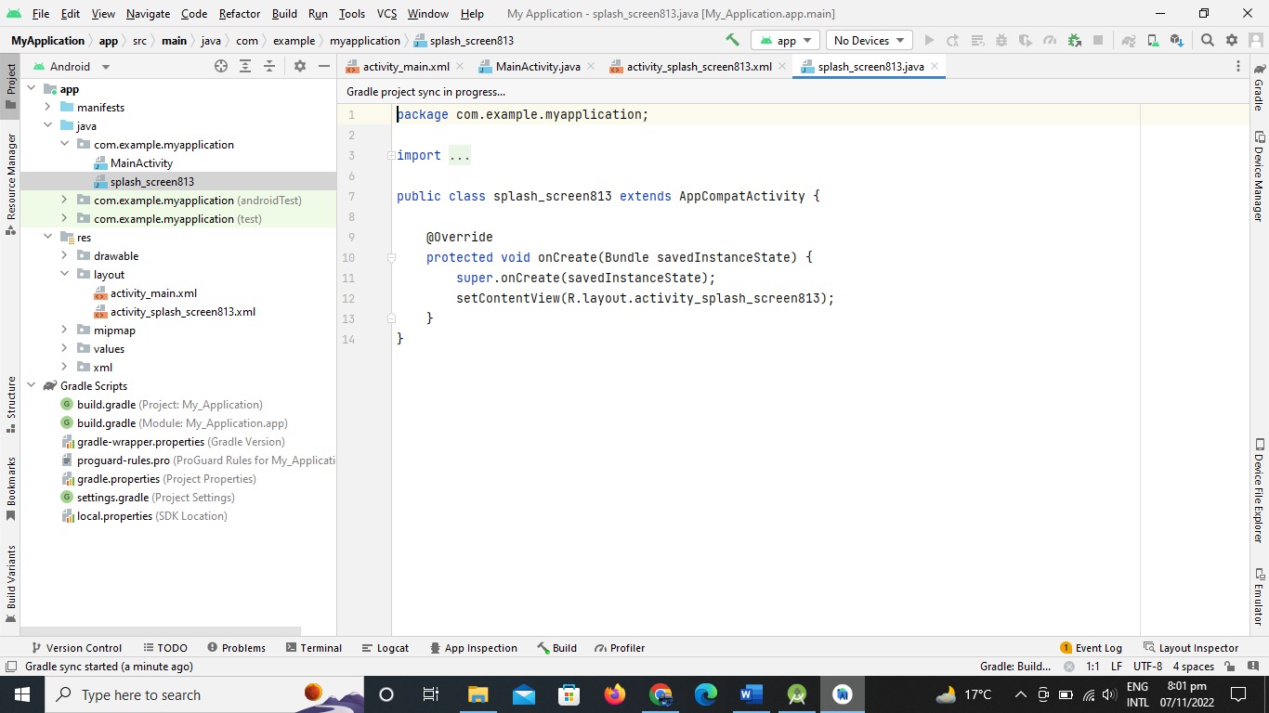

Then open res/layout/activity_splash_screen813

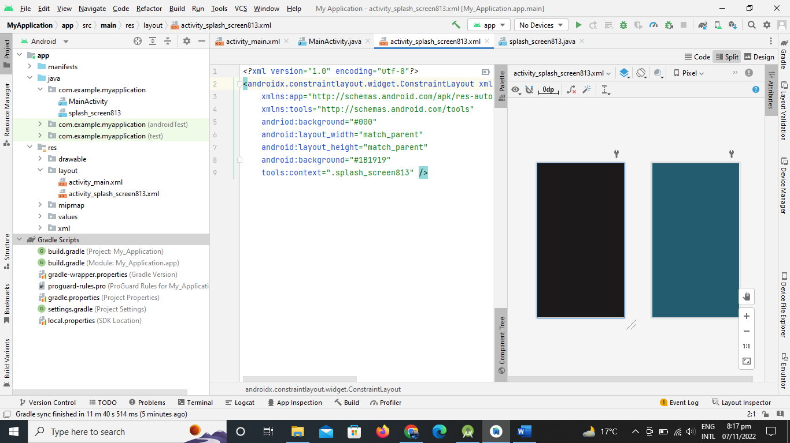

Then Add an image in drawable

Like drawable/image Asset/Action Bars and Tab Icons

Then give and path of image

My picture name is “native.png” 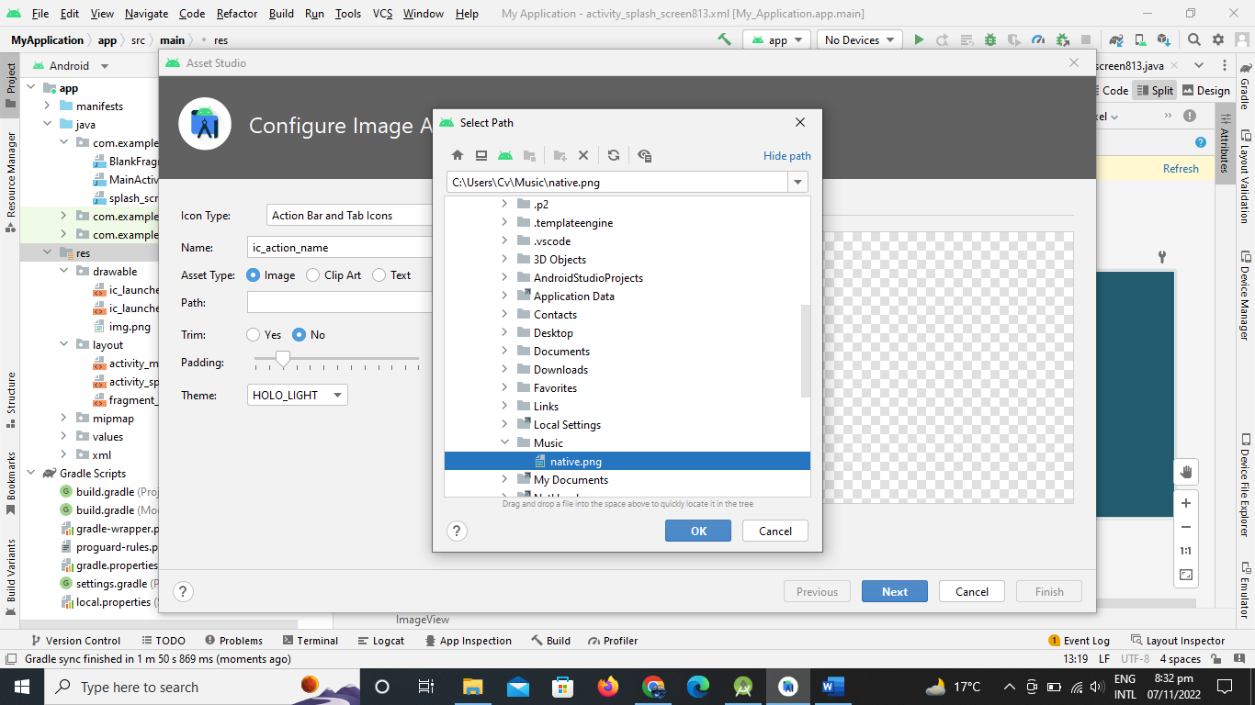

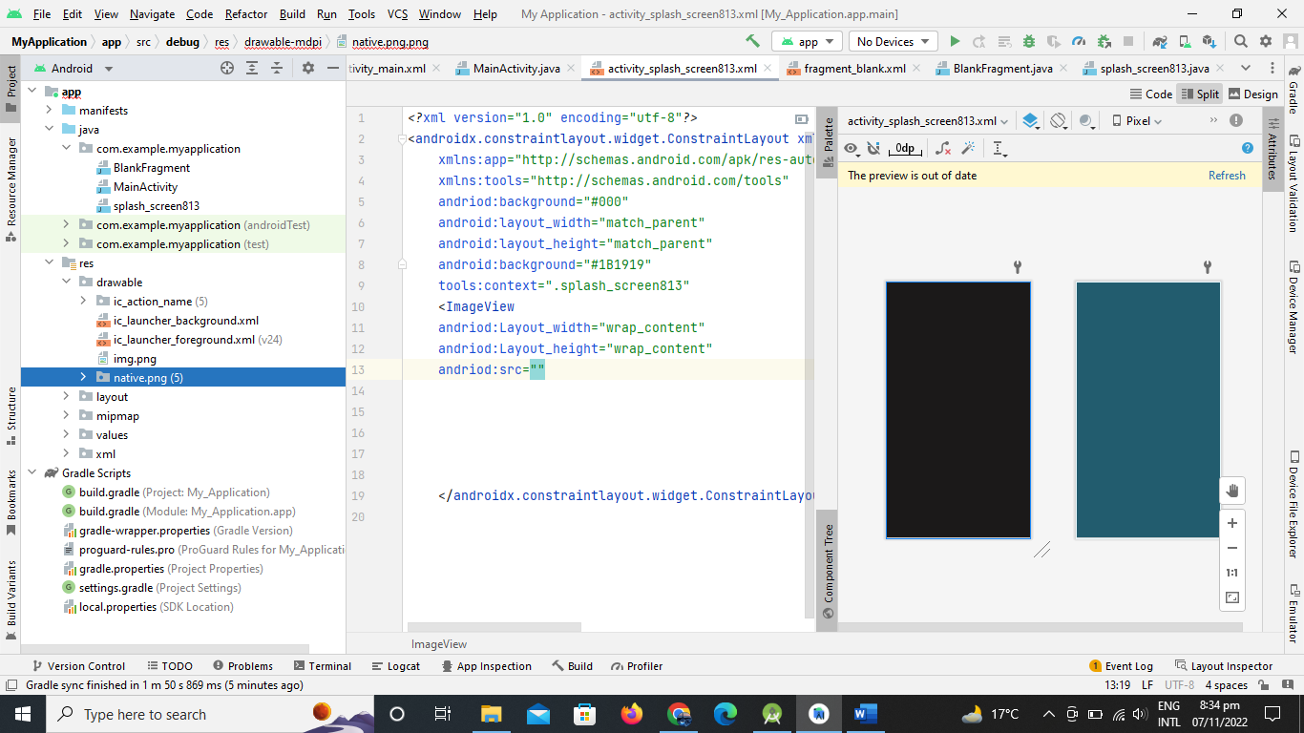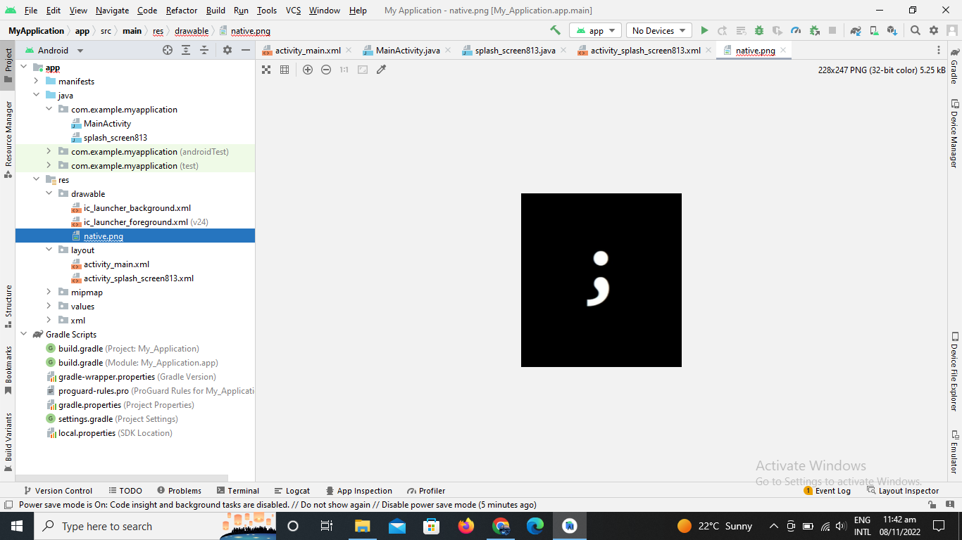

Then give some features to constraint layout

Like top end bottom

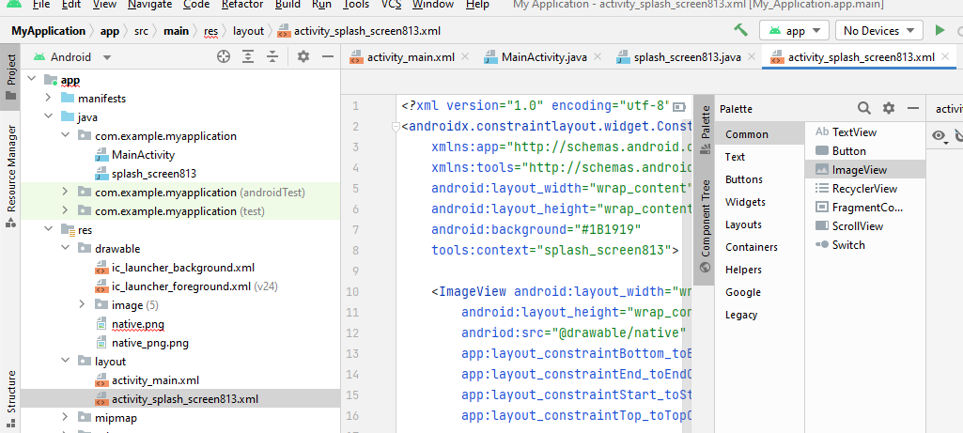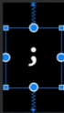

Like this

Two methods for splash screen

* Handler (multithreading purpose)
* Intent (move from one activity to another activity)

Write code in java class

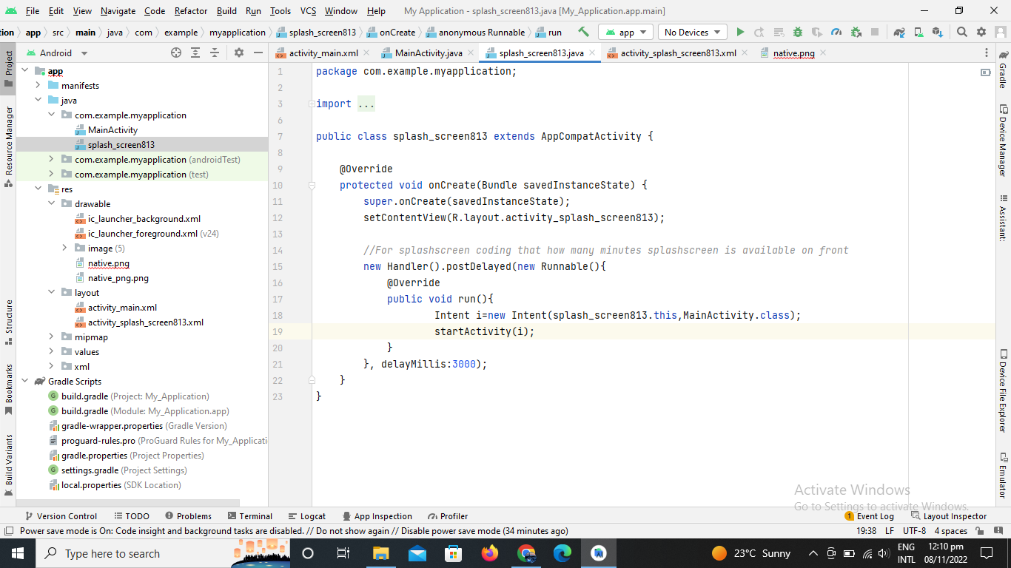

For better splash goes to res/values/themes

And marked “No Action Bar”

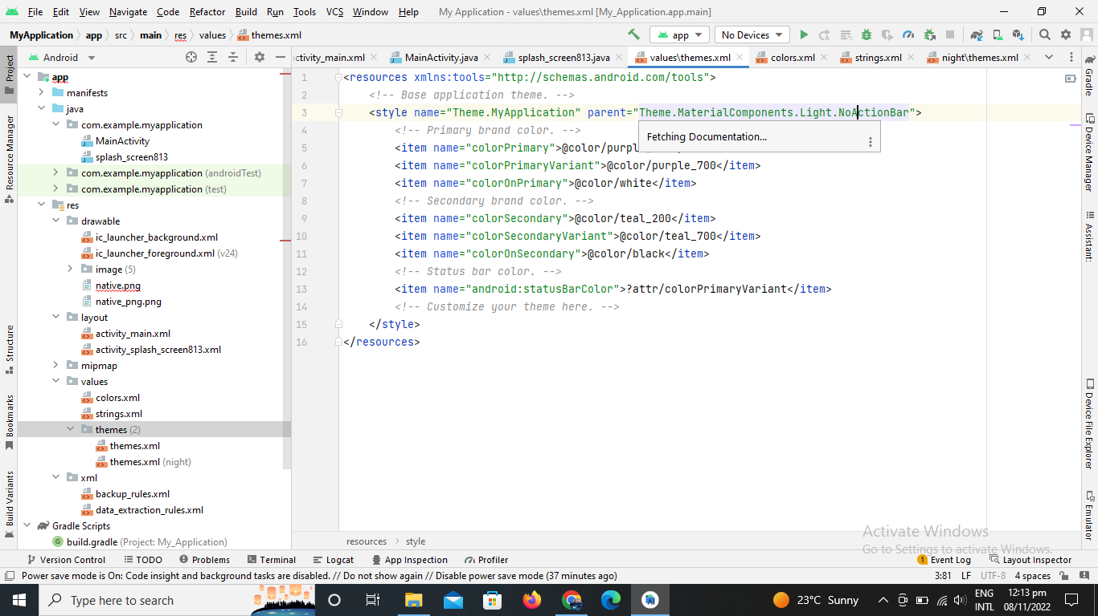

Then goes to AndriodManifest.xml

Cut the Intent part and paste into splash screen portion

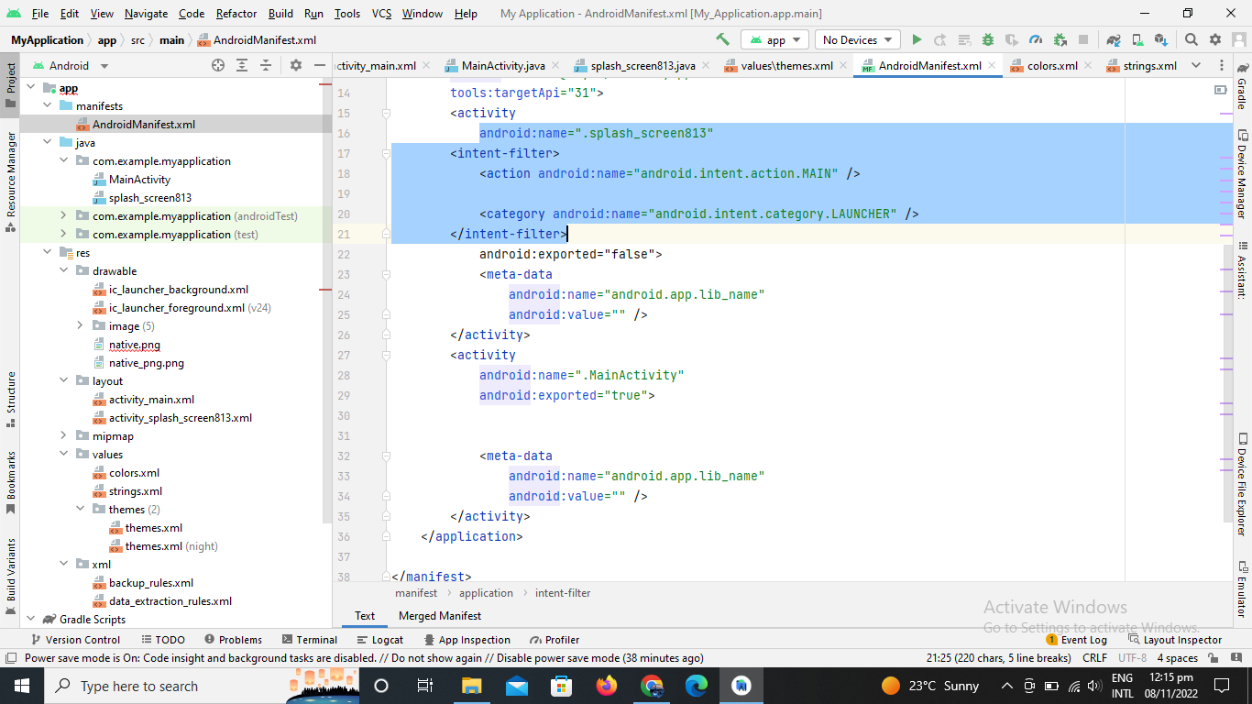

**Output:**

Splash screen will remain for 3 second and then go to previous page



Link:

[C:\Users\Cv\Pictures\Splash screen](Minahil%20Sajid%2019-Arid-813%20Assig%202%20MAD.docx)